Custom Form using QuickLink

Contents

1. QuickLink : 3

2. Steps to configure Quicklink : 3

3. Workflow 5

4. References: 5

## QuickLink :

QuickLinks are tasked-based links to frequently used areas of IdentityIQ. Your administrator determines the behaviour and availability of these links. QuickLinks are displayed as cards on the IdentityIQ Home page and as links in the QuickLink Menu.

## Steps to configure Quicklink :

1.configure Quicklink in debug page

2.navigate to system configuration 🡪 quickLinkCategories then add this

<QuickLinkCategory cssClass="quickLinkCategoryCustom" enabled="true" messageKey="quicklink_category_custom" name="Custom" ordering="4"/>

3.goto global settings 🡪QuickLink populations 🡪Everyone🡪QuickLinks

enable the Quicklink created.

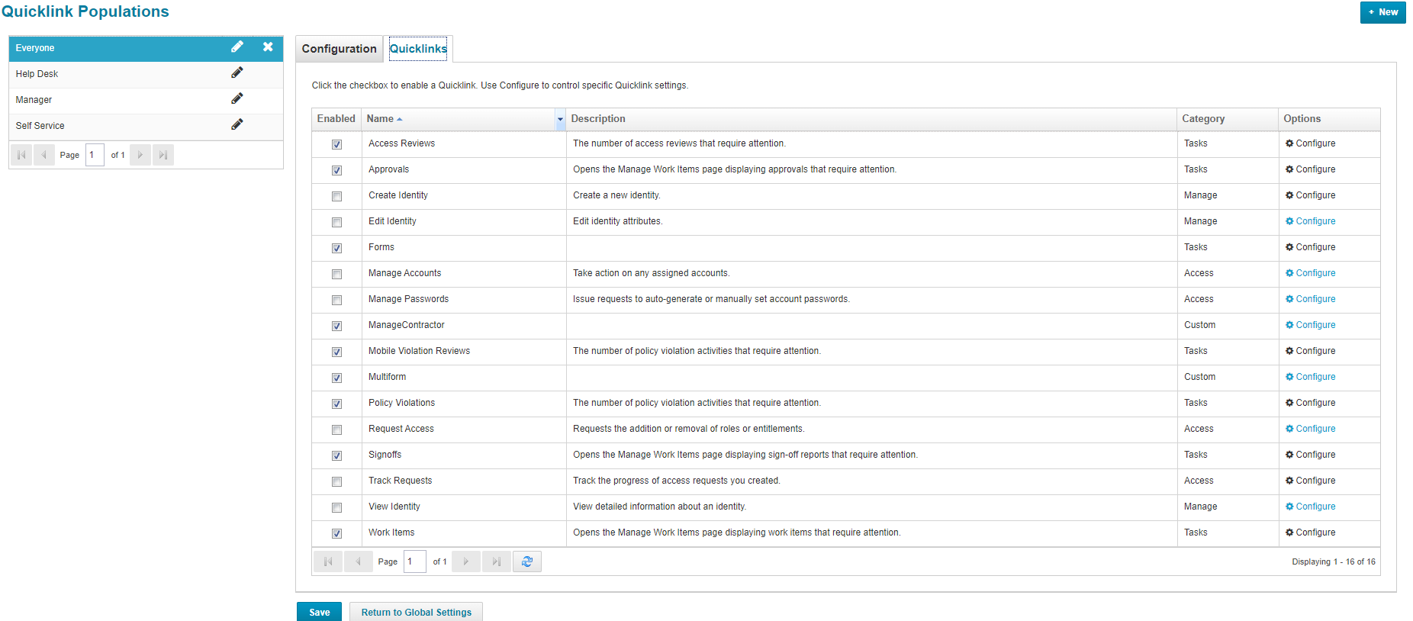

Then configure the Quicklink

4.Now Restart the server ,then the Quicklink will be displayed in Quicklink Cards.

5.Then click on it it will open the form in the workflow specified in the Quciklink.

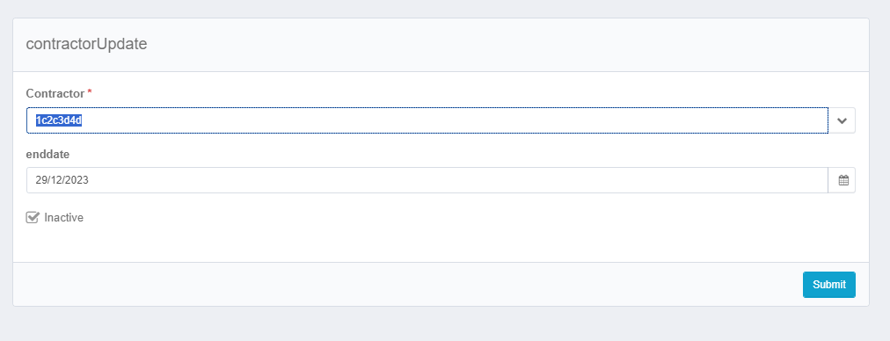

## Workflow

The Xml for the workflow is as follows:



* Here the usecase is as follows if the details of the contractor is already given ,then if we select that contractor then those previous values should be displayed for that we should use contractor field as dependency for both enddate and inactive fields.
* Since we are using the field contractor in the form before submission of it we have to take postBack=true for the field contractor.
* In the workflow we are using the help of identityModel object to store the fields in the form in a map format.
* Identity transformer will transform the identity into a map i.e., identity attributes will be stored as key value pairs.

## References:

1.[Steps to create QuickLink category and QuickLink - Compass (sailpoint.com)](https://community.sailpoint.com/t5/IdentityIQ-Wiki/Steps-to-create-QuickLink-category-and-QuickLink/ta-p/194326)

2. <https://community.sailpoint.com/t5/Technical-White-Papers/Forms/ta-p/73531>

3. <https://community.sailpoint.com/t5/Technical-White-Papers/Form-Models/ta-p/78498>